CET SEND Information Report 2025-26

Statutory policy cover sheet
Policy Type | Statutory | Yes
Published on Website | School | Yes
Published on Website | CET Trust | No
Policy Owners | SEND Team
Reviewed by Director of Education | Date : January 2026
Approved by Education and Standards Committee | Date : January 2026
Implementation date | January 2026
Next review date | January 2027
Other related policies | - SEND Policy  - Accessibility Plan
Editable by Schools | Yes

Version History

Version Number | Date | Page | Changes made | Reason for Change
6 | Jan 2026 | - | None | - N/a



THE MILTON KEYNES ACADEMY

SEND Information Report
January 2026

Contents
- Introduction
- What is SEND?
- What is disability?
- Accessibility
- What types of SEND are provided for at Milton Keynes Academy?
- iCREATE - Creative Education Trust approach to SEND
- What are the arrangements for assessing and reviewing student progress towards outcomes?
- Who should I contact if I want to find out more information or think my child has SEND?
- How do we know if the support we offer and provide is effective?
- What are the arrangements for consulting parents/carers of students with SEND and involving them in their child’s education?
- What are the arrangements for consulting students with SEND and involving them in their education?
- How does the school involve other bodies, including health and social care, local authority support services and voluntary sector organisations in meeting a student’s SEND and supporting their families?
- What are the arrangements for supporting students in moving between phases of education and in preparing for adulthood?
- What adaptations are made to the curriculum and learning environment for students with SEND?
- What expertise and training do staff complete to support students with SEND?
- How do students with SEND engage in the activities available with those in the school who do not have SEND?
- What support is available for improving students’ social and emotional development?
- Why is Attendance Important for pupils with SEND – How leaders and staff support attendance in school.
- What are the arrangements for handling complaints from parents/carers of students with SEND about the provision made at the school ?

- Introduction

Welcome to our SEND Information Report 2026, which forms part of the Milton Keynes Local Offer for learners with Special Educational Needs or Disability (SEND) in accordance with the Special Educational Needs and Disability Code of Practice, January 2015 (Chapter 6, section 6.79). This report is also fully compliant with Regulation 51 and Schedule 1 of the Special Educational Needs and Disability Regulations 2014. The information published will be updated annually.
The Information Report also applies to all pupils who are looked after by the local authority and have SEND.
This document has been designed to advise families with children who present with Special Educational Needs, Disabilities and or are vulnerable, on the provision available at Milton Keynes Academy. It should guide families when deciding if Milton Keynes Academy is the right educational setting for their child.
When we talk about “provision”, we mean what we provide to meet the needs of a pupil and help them to make progress at school which is appropriate to their age.

- What is SEND ?

At different times in their school career, a child or young person may have a special educational need. The May 2015 Code of Practice defines Special Educational Need and Disability (SEND) as:
A child or young person has SEND if they have a learning difficulty or disability which calls for special educational provision to be made for them. A child or young person of compulsory school age has a learning difficulty or disability if they:
(a) have a significantly greater difficulty in learning than the majority of children of the same age; or
(b) have a disability which prevents or hinders them from making use of facilities of a kind generally provided for others of the same age in mainstream schools or mainstream post-16 institutions.

If a child or young person is identified as having SEND, Milton Keynes Academy will make provision which is “additional to” or “different from” that provided for non‐SEND students (the ordinarily available provision adapted through the curriculum through Quality First Teaching), which is intended to overcome any barriers to their learning.

It is important to note that not every pupil making slower progress has SEND. Some pupils may make slower progress for a reason unrelated to SEND, such as a gap in their learning. Additionally, children and young people must not be regarded as having a learning difficulty solely because the language or form of language of their home is different from the language in which they will be taught. However, some students for whom English is an additional language may also be identified as SEN if their needs meet the criteria above.

- What is Disability ?

The Equality Act, 2010, gives the following definition of disability:
“A person has a disability for the purposes of this Act if they have a physical or mental impairment which has a substantial and adverse long‐term effect on their ability to carry out normal day‐to‐day activities.”
This definition of disability includes children and young people with long‐term health conditions such as asthma, diabetes, epilepsy and cancer. Children and young people with such conditions do not necessarily have SEND, but there is a significant overlap between disability and SEN. A child or young person may therefore be covered by both SEN and disability legislation.
Our facilities for helping disabled students to access the school are described fully in the school's Accessibility Plan (https://www.miltonkeynesacademy.org.uk/_site/data/files/about/policies/BCE00CD3CAA75DB1179E45EB2E07A2ED.pdf).
If parent carers feel there is a need to highlight an on going health or medical need Milton Keynes Academy will always consider appropriate arrangements to support and include these needs and where necessary a medical health care plan will be devised and co-ordinated by Mrs Rambini.

- Accessibility

Our school is a safe and accessible building, and we do our best to make it welcoming to the whole community. All safeguarding procedures and risk assessments are in place and adhered to by all staff. We have a range of different facilities to help SEND students throughout our school including: a lift to access all floors, disabled toilets, a disabled changing facility and appropriate corridors.

- What Types of SEND are provided for at Milton Keynes Academy?

There are four broad areas of need, although the Trust and Milton Keynes Academy recognise that a student’s needs may fall into one or more categories. Milton Keynes Academy provides provision for all areas of need in line with the appropriate provision pupils require.
- Communication and Interaction (C&I): Children and Young people with speech, language and communication needs (SLCN) have difficulty communicating with others. This may be because they have difficulty saying what they want to (expressive), understanding what is being said to them (receptive/cognition). They may not understand or use social rules of communication. Pupils with Autistic Spectrum Conditions (ASC) including Autism or Aspergers can have more prevalent difficulties with social interaction due to deficits in their understanding and connections between language, communication and imagination, which then impacts on how they relate to others.
- Cognition and Learning (C&L): A broad ranging group of learning difficulties including Dyslexia and Dyspraxia as Specific Learning Difficulties (SPLD), Moderate Learning Difficulties (MLD), Severe Learning Difficulties (SLD) where children and young people will need support in the curriculum and may have associated mobility and communication difficulties, to those with Profound and Multiple Learning Difficulties (PMLD) where children and young people have severe and complex learning difficulties with physical disability and/or sensory impairment.
- Social, Emotional and Mental Health (SEMH): Children and Young people diagnosed with Attention Deficit Disorder (ADD) or Attention Deficit Hyperactivity Disorder (ADHD) or Attachment Disorder may need additional support in the curriculum. Those with Mental Health Difficulties such as anxiety, depression, self-harming, substance abuse, eating disorders or physical symptoms that are medically unexplained may also need additional or different support to access education.
- Sensory and or Physical Needs (SI/PD): Children and Young people with Hearing (HI) need additional specialist support or equipment to access the curriculum, or rehabilitation support. Some with physical disability (PD) may need additional and ongoing support to enable them to access opportunities available to their peers. SEND provision may be required as they have a disability that prevents or hinders them from making full use of educational facilities generally provided.

- iCREATE - Creative Education Trust approach to SEND

Creative Education Trust have a robust SEND framework iCREATE, which provides a comprehensive outline of how Milton Keynes Academy identifies, assesses and provides for the full range of SEND needs. The framework also outlines the Ordinarily Available Provision for all pupils, as we understand that support for SEND starts with effective Quality First Teaching for all. Additionally, the framework provides an outline of how Milton Keynes Academy supports a graduated response for all pupils in line with Special Educational Needs and Disability Code of Practice: 0 to 25 years.

This detailed framework can be found here : https://www.miltonkeynesacademy.org.uk/about-us/policies

iCREATE uses a focus on the following 7 areas :
i | Inclusion
C | Creativity
R | Respect
E | Excellence
A | Ambition
T | Therapeutic Awareness
E | Emotionally Literate

At Milton Keynes Academy you will see each element of iCREATE through the following strategies:
Inclusion
This promotes access to education for all children and young people through accurate identification of needs and through the development of individualised and group/ community approaches that foster equal access to the curriculum irrespective of individual needs. The use of a fully graduated response is crucial to this as is the effective use of Assess, Plan, Do, Review (APDR).
Creativity
Utilising creative partnerships at all levels. This includes effective co-production with all stakeholders, especially children and young people and parent carers. This element also supports the creative ability to match the pastoral needs of all children and young people, bearing in mind the reasonable adjustments needed to address any social contextual challenges, such as ACEs and still achieve the best outcomes.
Respect
The promotion of positive values across the whole community of the academies including leadership impact, linking into the effective partnerships between different stakeholders, especially children and young people and parent carers. A key element of this section is the development of safe environments that remove any stigma or bias and reduce bullying opportunities that are sustained to zero.
Excellence
The offer of a high-quality experience in all our academies requires the co-ordination of planned and effective Continuous Professional Development (CPD) to enable all practitioners, including leaders, teachers, learning support and all practitioners to deliver a positive contribution to the progress of all children and young people and the sustaining of a skilled and informed workforce.
Ambition
A genuine focus on effective target setting allows children and young people to build on their own ambitions and develop a ‘no limits’ approach to both their academic and social development. The drive to ensure ambition is key, also supports a cycle of success that can be transformative for children and young people.
Therapeutic Awareness
A secure understanding of neuroscience enables both staff and children and young people to increase their ability to access learning more effectively. This includes an awareness of sensory needs and the physical environment, and an understanding of what resources can help to mitigate barriers and promote the cycle of success.

Emotionally Literate
Building on an increased awareness of Therapeutic approaches, staff and children and young people focus on how to communicate their emotions and needs most effectively. This includes modelling language and behaviour and utilising the practical knowledge base through activities that help further promote self-regulation and ultimately create the foundations for positive relationships and an improved ability to manage conflict resolution.

- What are the arrangements for assessing and reviewing student progress towards outcomes?

All pupils, including those with SEND, are assessed on a regular basis, in accordance with the academy’s assessment policy. Teachers formally assess and review progress and attainment, which is communicated to parent carers by a report that is sent home once a year, with updates on the Arbor after each assessment point which parents can access. Additionally, parent carer evenings are held annually when there is an opportunity to discuss progress, attainment and next steps.
Pupils at Wave 2 of the graduated response (See iCREATE) may have a pupil passport that is co-produced with the pupil and shared with parent carers for comments and support. Passports outline strategies and agreed targets to support progress and are assessed as often as required but at least every term.
Pupils with SEND who are identified at Wave 3 or 4 of the graduated approach (See iCREATE) will have termly Assess Plan Do Review APDR’s cycle, these are reviewed each term with new targets co-constructed pupils and parents where appropriate.

All students with an Education, Health & Care Plan have an Annual Review (EYFS will be bi-annually), where a discussion is held around progress towards meeting the outcomes stated in the plan. This is conducted with all stakeholders including parent carers and pupils. Amendments to the plan can be made, which when agreed by the Local Authority, should lead to a reviewed and updated plan.
At times, when needs appear to change more quickly, an emergency annual review may be considered in order to ensure the EHC plan remains fully appropriate.
Pupils who have been assessed as needing support with SEND are placed our Special needs register. Parent carers and pupils will all be informed if this is required. Pupils can be placed on the register at any time and sometime will only need to be on the register for a short time. If the academy is able to address the initial need and support the pupil through our ordinarily available provision the pupil may be taken off the register, when this happens it is always discussed with parent carers and pupils.

The register on the 7th of January 2026 was made up of the following SEND :

Area of need | No. of pupils at SEN support | No. of pupils with an EHC plan
Cognition & Learning | 102 | 4
Communication & Interaction | 34 | 8
Social Emotional Mental Health | 72 | 2
Physical | 0 | 14
SEN – All | 222 | 14

- Who should I contact if I want to find out more information or think my child has SEND?

If you have any concerns about your child’s progress, your first point of contact should always be the form tutor/ class teacher. Following this communication, the form tutor/ class teacher will contact the SEND team to discuss these concerns, if appropriate.
This is the first step in the graduated response of a pupil’s needs.
The contact details for members of staff who are able to support students and families with additional needs are:
Mrs E Akinsoyinu | Miss V Garcia
Director of SEND | Deputy SENDCo

Contact –MKA-Inclusion@miltonkeynesacademy.org,uk
Telephone – 01908 341700

- How do we know if the support we offer and provide is effective?

Progress at Milton Keynes Academy is underpinned by our Teaching and Learning framework https://www.miltonkeynesacademy.org.uk/_site/data/files/about/policies/C6B3EC32FED51EBDB26040DCD1FAE5D2.pdf. We continuously ensure the provision we provide has a positive impact on the outcomes for all of our pupils. Pupils’ academic progress is monitored termly through live marking and checks for understanding as well as through department and cross trust assessment points. Each department has a minimum of one assessment point per half term. The progress of pupils with SEND is monitored by both the class teacher and the SENDCo using summative assessments and day to day informal assessments that can be made during lessons and interventions. The information regarding progress is then used to evaluate the effectiveness of the support given. We also gather information from pupils, parent carers as well as professionals from other agencies. The impact of interventions can be measured through SMART target setting at the start and by reviewing progress at the end. This can be in the form of data, for example reading age or standardised scores or, in the case of social interventions, progress can be evaluated by whether or not the pupil has met the targets set out at the start of the programme e.g in their pupil passports.
Other methods of our evaluation include:
- Provision Mapping
- SENDCo/SLT/Academy Counsellor monitoring
- Performance Management Targets
- SEND Quality Assurance visits
- Teaching and Learning Audits
- Intervention Impact Reports
- Pupil passports
It is of the upmost importance to us that the provision we provide is effective and therefore we regularly review its impact. The SENDCo reports the impact, evaluation and effectiveness of provision to the Senior Leadership Team, academy council and various improvement panels on a regular basis.

- What are the arrangements for consulting parent carers of pupils with SEND and involving them in their child’s education?

We take our responsibility to work with parent carers very seriously. We strive at all times to provide the information needed for parent carers to make informed decisions about their child’s education.

- We will work to ensure that everyone is clear on what the agreed outcomes are for the child and what the next steps are to achieve these.
- We will work to develop a strong understanding of the pupil’s areas of strength and where additional support is needed.
- We will take into account parental concerns and work towards solutions as quickly
as possible.
- We notify parent carers when it is decided that a pupil will receive SEND support
(Wave 3).

We will draw attention to available support outside school (e.g. Special Educational Needs and Disability Advisory Support Service - S.E.N.D.I.A.S.S. (formerly Parent Partnership Service https://mksendias.org.uk/ and the Local Offer https://www.mksendlocaloffer.co.uk/.

Parent carers can support the school by encouraging the pupil to fully engage with their learning and any interventions offered by:
- Helping them to be organised for their day ( bringing the right equipment )
- Full attendance and good punctuality
- Completion of homework
- Attending parent carer meetings
- Attending any meetings specifically arranged for your child
- Ensuring any additional information parent carers feel is important is communicated in a timely way

- What are the arrangements for consulting pupils with SEND and involving them in their education?
All pupils are encouraged to take part in pupil voice activities; regularly evaluate their work in lessons; attend review meetings; contribute to the assess, plan do and review process and reflect on their learning and achievements. Mentoring takes place where pupils have detailed discussions with their form tutor / class teacher/ key worker / pastoral team about their attainment, progress and next steps for improvement.

Pupils with SEND will be given additional opportunities to share their voice with allocated time with members from the SEND team.

- How does the school involve other bodies, including health and social care, local authority support services and voluntary sector organisations in meeting a student’s SEND and supporting their families?

Milton Keynes Academy has developed effective working relationships with a wide range of external partners, professionals and agencies. These services are contacted when necessary and appropriate, according to a pupils’ needs. The school works closely with Milton Keynes City Council and we use the Early Help Assessment process when appropriate to do so.
A variety of support services are available for the parent carers of pupils with SEND, which can include access to advice and support from Education Psychology, Speech and language Therapy, school nursing services and Occupational Therapy, if they are available and needed. More information about this support can be accessed through the following forms of communication:
Early Help Assessment – https://www.milton-keynes.gov.uk/children-young-people-and-families/early-help
School Nursing Team- https://www.cnwl.nhs.uk/services/community-services/milton-keynes-0-19
Special Educational Needs and Disability Information, Advice and Support Service
(SENDIASS) – https://www.milton-keynes.gov.uk/sendias

The Local Authority local offer is available on its website by following this link:
https://www.milton-keynes.gov.uk/schools-and-lifelong-learning/SEND

- What are the arrangements for supporting students in moving between phases of education and in preparing for adulthood?

Transitions can be a complex and daunting time for some pupils. These transitions can include:
- Moving to our Academy from primary school or another secondary school
- Moving from our Academy to another secondary school
- Moving classes or groups within school
- Having a new teacher
- Moving from our Academy to work, college or university

Milton Keynes Academy is committed to working with pupils, their parent carers and families, and other settings/providers to ensure that we use foresight and our collective expertise to ensure that positive transitions occur.
Planning and support for transition is a particular and important element of our provision for all SEND students at Milton Keynes Academy.
Planning for transition from Year 6 to secondary school begins within Upper Key Stage 2. For those students with EHCPs, the SENDC team will liaise with the primary schools (and parent-carers where appropriate) prior to starting in Year 7 to ensure that provision is in place and there is as smooth a transition as possible.
From Year 8, transition planning starts for the move into Key Stage 4 and from there into sixth form, college or employment. The SENDCo and form tutors work closely with other providers and settings to ensure a transition which is as smooth and positive as possible for students with SEND.

For pupils with an EHCP, additional information is gathered and shared with future education providers, ensuring the most appropriate provision and support is available.

- What adaptations are made to the curriculum and learning environment for students with SEND?

Most of our pupils follow a broad and balanced curriculum, however, a small number of students have a more personalised approach to the curriculum to match their individual needs, interests and abilities and allow them to make use of adaptations to support their access to an inclusive approach. This may include option choices, additional literacy or other intervention groups.

- What expertise and training do staff complete to support students with SEND?

Annual training covering various aspects of SEND is offered to all staff as part of the Trust and Academy’s Continuous Professional Development (CPD) programme. Staff have received and continue to receive training across all areas of need identified in the SEND Code of Practice.
The following members of staff has completed, the National Award for Special Educational Needs Co-ordinator - Mrs E Akinsoyinu – Director of SEND.
Additionally, the following members of staff have qualifications related to SEND: Mrs V Garcia – Deputy SENDCo.

- How do students with SEND engage in the activities available with those in the school who do not have SEND?

A large range of academic and hobby/interest clubs are available at Milton Keynes Academy. These are open to all students, including students with SEND; the timetable is available on the school’s website/ shared with parent carers. https://www.miltonkeynesacademy.org.uk/personal-development/clubs

Pupils are encouraged to take part in the following additional initiatives :
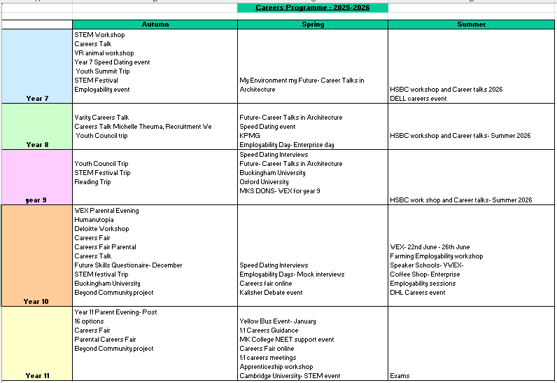

- What support is available for improving students’ social and emotional development?

At Milton Keynes Academy we take our pastoral responsibilities seriously. We pride ourselves on providing a high level of pupil support and guidance. One way we support our pupils is:
- Discussing students as part of a Highly Vulnerable Student Panel, to ensure that appropriate support in put into place.
- Year Teams write pastoral passports to support students and ensure that this information is shared across the staff body.
- There are additional members of staff who can provide pastoral support, these include: Safe Guarding Team, Year Team, SEND Team, EBSA Team, Ruston Team, SLT Team.
Creative Education Trust has entered a partnership with Therapeutic Thinking Ltd to provide training, guidance and advice regarding how to support increased awareness and self-regulation for pupils at Milton Keynes Academy.

- Why is Attendance Important for pupils with SEND –
How leaders and staff support attendance in school.

Attendance at Milton Keynes Academy is a primary focus for all pupils and students, but is particularly important for pupils who have SEND.
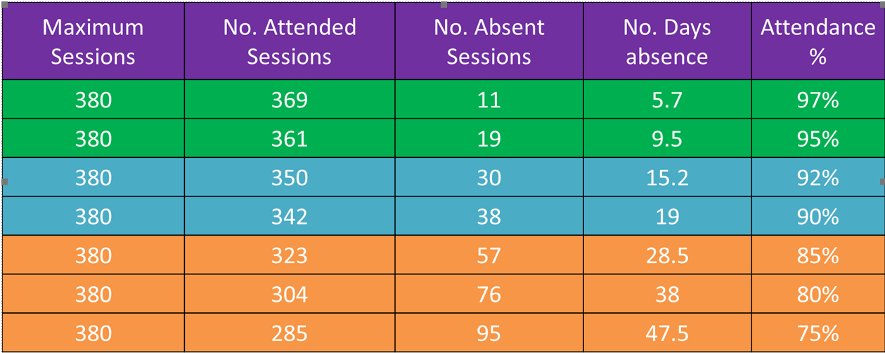
The impact of days lost for pupils with SEND can be greater than for pupil who do not have SEND. We would like all our pupils to attend every day and achieve 100 % attendance, but appreciate that some pupils with SEND may find this challenging due to medical appointments for example. The table below outlines how the percentage is impacted by the days missed at school.
At Milton Keynes Academy we will contact parent carers informally if there are growing concerns in relation to attendance. This may take the form a of a phone call or email or another agreed form of communication. This reach out to parent carers is intended to help create a supportive approach to enable attendance to be as close to 100% as possible, but particularly to stay above the target rate of 95% which means less than 10 days off school per year.

If attendance for any pupil with SEND falls below 95%, The SENDCo will work in partnership with attendance leads at the Milton Keynes Academy and if needed wider multi agency support, e.g. educational psychology or medical professional services and this approach may support attendance with an agreed plan, which parent carers will be invited to co-produce with the Milton Keynes Academy. These plans will record all the individual and unique context and challenges that our pupils with SEND have to navigate such as medical appointments and issues relating to mental health and other identified needs.

19.What are the arrangements for handling complaints from parents/carers of students with SEND about the provision made at the school ?

We hope that by maintaining a regular dialogue between parent carers and school the need to raise a complaint will be minimised. However, if you do need to raise a complaint about any issue relating to SEND, the process is outlined below:
  - Contact the SENDCo (unless the complaint is directly regarding the SENDCo, then contact the principal or refer to the academy complaint policy) - Ena Akinsoyinu, Director of SEND, MKA-inclusions@miltonkeynesacademy.org.uk 01908 341700. The opportunity to initially attend a meeting will be arranged to discuss and work towards a resolution of your complaint.
  - Should the complaint not be resolved satisfactorily at the meeting please refer to Milton Keynes Academy complaints policy on the school’s website. Should the complaint not be resolved satisfactorily at the meeting please refer to Milton Keynes Academy complaints policy on the school’s website. https://www.miltonkeynesacademy.org.uk/about-us/policies

References / Examples
Special Educational Needs and Disability Code of Practice: 0 to 25 years (published by the Department for Education, January 2015) and available for download at https://www.gov.uk/government/publications/send-code-of-practice-0-to-25
Pupil Passport Example
